Study and manipulation of the quantum properties of atomically engineered structures in silicon for future device applications

Neil Curson (UCL) and Gabriel Aeppli (Paul Scherrer Institute)

We are inviting applications for a fully funded 4-year PhD project in the area of Atomic-scale Quantum Physics and Technology in the research group of Dr Neil Curson at the London Centre for Nanotechnology, University College London, and project partner Professor Gabriel Aeppli from the Paul Scherrer Institute (PSI), in Zurich. This funding stream allows applicants to be home students or European Union students.

The project involves the exploitation of dopants in silicon to fabricate and study novel quantum systems. The research will impact on future integrated circuit technology as devices continue to shrink and will also lead to advances in more exotic device architectures such as quantum computers. The student will perform electro- and magneto-optical measurements of STM-fabricated devices. The measurements will be in the spectral and time domain, and will demonstrate coherent control of donors in silicon in the far and mid infrared. The work includes assisting in the commissioning of a new purpose-built Dilution Refrigerator (DR) for measurements in the milli-Kelvin regime and hands-on construction of optical setups, in addition to carrying out low temperature and low noise measurements of quantum devices. The DR measurements will be made at PSI in Zurich, where the student will be based for 50% of their time. One unique aspect of the experimental set-up at PSI is the coupling of the DR to the infrared beamline of the Swiss Light Source synchrotron. The beam provides a continuous photon flux that is 100 times larger than for laboratory-based sources.

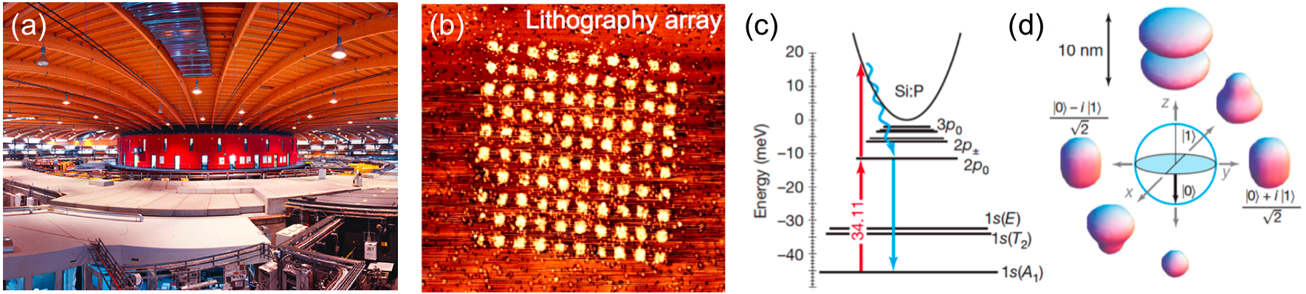
(a) The Swiss Light Source synchrotron facility at PSI, (b) a lithographically patterned array of holes in a hydrogen resist, made by using the STM tip to controllably remove hydrogen atoms, (c) the energy levels of the P donor electron in silicon, (d) different coherent superpositions of the 1s(A) ground state and the 2p0 excited state [Greenland et al, Nature, vol. 465, 1057 (2010)].

At UCL you will be joining a research team who have pioneered a scanning tunnelling microscopy (STM) hydrogen resist technique, which can make small quantum defect structures from phosphorus (P) and arsenic (As) dopant atoms buried below a silicon surface. The project involves the fabrication of few and single dopant atom devices from silicon samples where the dopants are incorporated using STM hydrogen resist lithography, exploiting the techniques of scanning tunnelling microscopy (STM), chemical vapour deposition (CVD) and molecular beam epitaxy (MBE). Fabrication also includes using the cleanroom techniques of electron beam lithography (EBL), reactive ion etching (RIE) and metal evaporation, plus other standard processing techniques, and particular emphasis will be placed on this aspect of the work. UCL has an extensive optics laboratory and some sample characterisation will be performed there. The student will also undertake a training programme at UCL and Imperial College London, as a member of the Centre for Doctoral Training in Advanced Characterisation of Materials.

We seek candidates for October 2018 entry. You will hold, or be expected to achieve, a Master's degree in addition to a Bachelor's degree (or equivalent) at 2:1 level (or above) in a relevant subject (e.g. Physics or Engineering). The closing date for applications is 19 August 2018.

Applications will be handled in two stages:

Stage 1: Send a full CV, including the marks (%) for all (undergraduate) modules completed to date and including a clear description of previous research project experience, as well as a covering letter and contact details of two academic referees, to Dr Neil Curson (n.curson@ucl.ac.uk). Applications that do not provide this information cannot be considered.

Stage 2: Suitable applicants will be interviewed, and if successful invited to make a formal application.

